|  |  |  |
| --- | --- | --- |
| f |  |  |
| **Benha University** |  | **Faculty of Computers & Artificial Intelligence** |

**Pharmacy Management System**

**In**

Information System

**by**

|  |  |
| --- | --- |
| Eslam hany elsayed zoghla (Section 4) | Aya Mahmoud saber elgamal (Section 6) |
| Eslam hamdy ragab (Section 4) | Eman ibrahem elbadwy (Section 6) |
| Abdullah ahmed Hussain (Section 12) | Alaa nabwy ragab elmastouly (Section 5) |

**Supervised by :**

***Eng: Marah Mostafa***

Table of Contents

1. Abstract 1

2. Introduction 1

3. Content 2

4. Rules and Service Button: 6

5. Insert drugs : 7

6. Update Buttons: 9

7. Delete Buttons: 11

8. View all Books Button : 13

# Abstract

**Pharmacy Management System** is a system that stores data and enables functionality that organizes and maintains the medication use process within pharmacies.

This system serves many purposes, including the safe and effective dispensing of pharmaceutical drugs. During the dispensing process, the system will prompt the pharmacist to verify the medication they have ended or need

An information of drugs

Introduction

is any system used in a pharmacy that helps automate the pharmacy workflow. This includes such tasks as reviewing physician orders and preparing medications, controlling the inventory and making drug orders, handling billing and insurance, providing counseling, identifying incompatibilities, and more — all while following legal protocols and compliances.

And these are just the traditional functions that can be automated. Many more features can give the pharmacy a competitive edge by providing better customer experience and attract patients with more personalized and engaging service. We will talk in detail about such features in the following section. Now, let’s go through the main benefits a pharmacy management system will help you get.

# Content

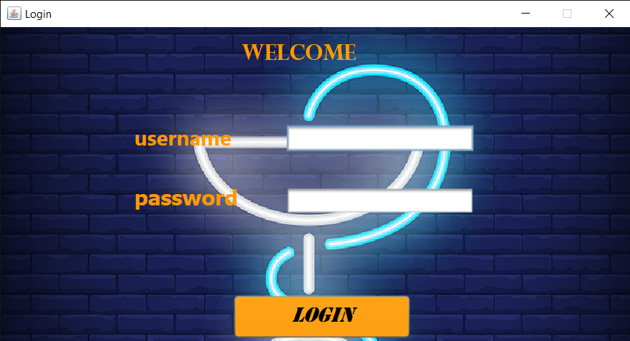

This is Login frame with username and password from database.

This frame is used to add or remove data from database.

If we need to add an element to database we sould click add to show panal(Add Drugs) then write all information about drugs and click add again to show in table .

If we went to save in database click save or delete to delete it.

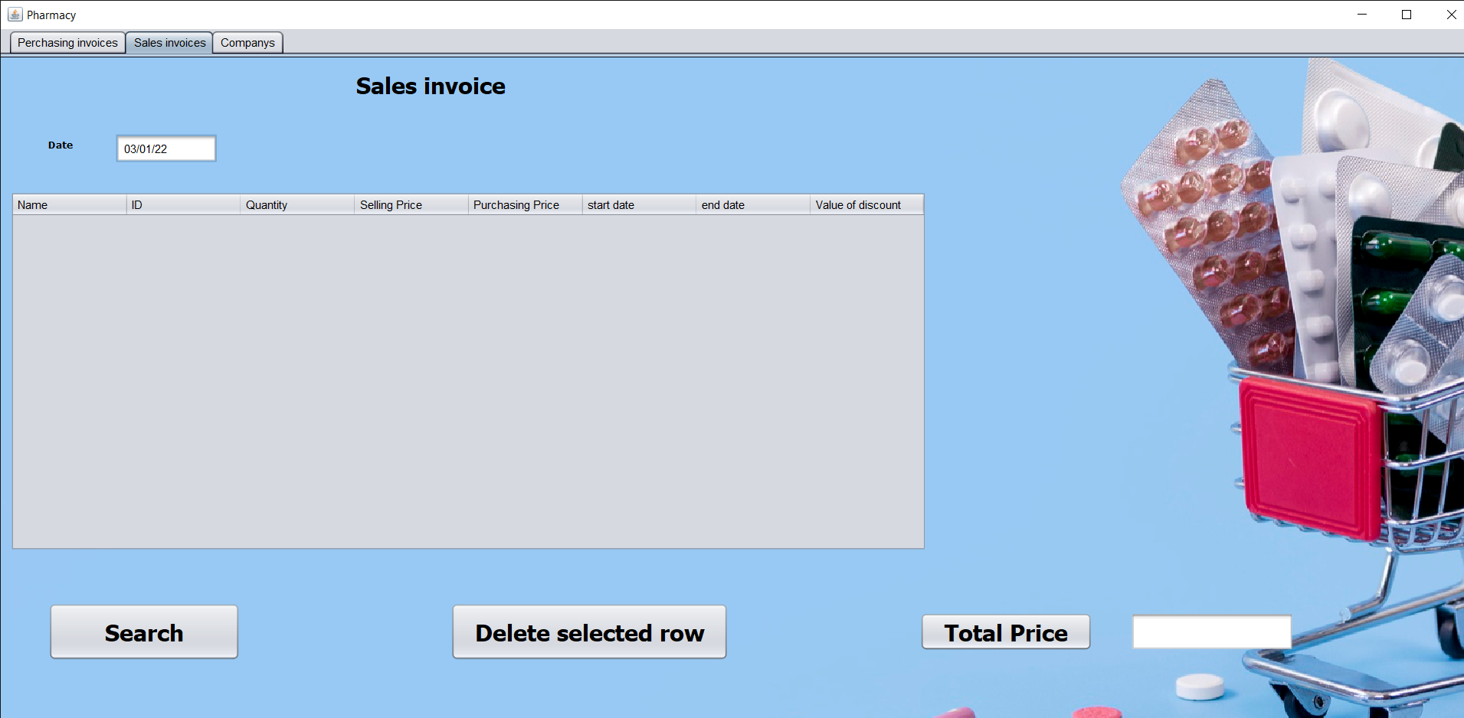this frame to sales:

* A screenshot of a computer

  Description automatically generatedFirst : we click Search to search about order by id

The result will showing in table then click OK to add to sales tables.

This frame is shown companys it contant buttons

(Add ,Save,Update,delete)

If we need to add a company to database we sould click add to show panal(Add company) then write all information about company and click add again to show in table .

# Rules and Service Button:

This is class contant a constractor and :

- Default date is used to show the current data .

- connection between database(Mysql) and java GUI.

1. Text

   Description automatically generatedInsert Buttons:

This button from frame one used to add drugs to database.

And this to add new company to database .

# Update Buttons:

This code used to update information about drugs in datacase.

This used to update information about company

In database.

# Delete Buttons:

This used to delete drugs from data base.

and this to delete information about company from database.

# View all Drugs in database :

To view all Drugs in Data List (Library).

This used to show all companys in database.

**This Code to make mouse action click and add to text Field.**

**This is all import and private varible.**